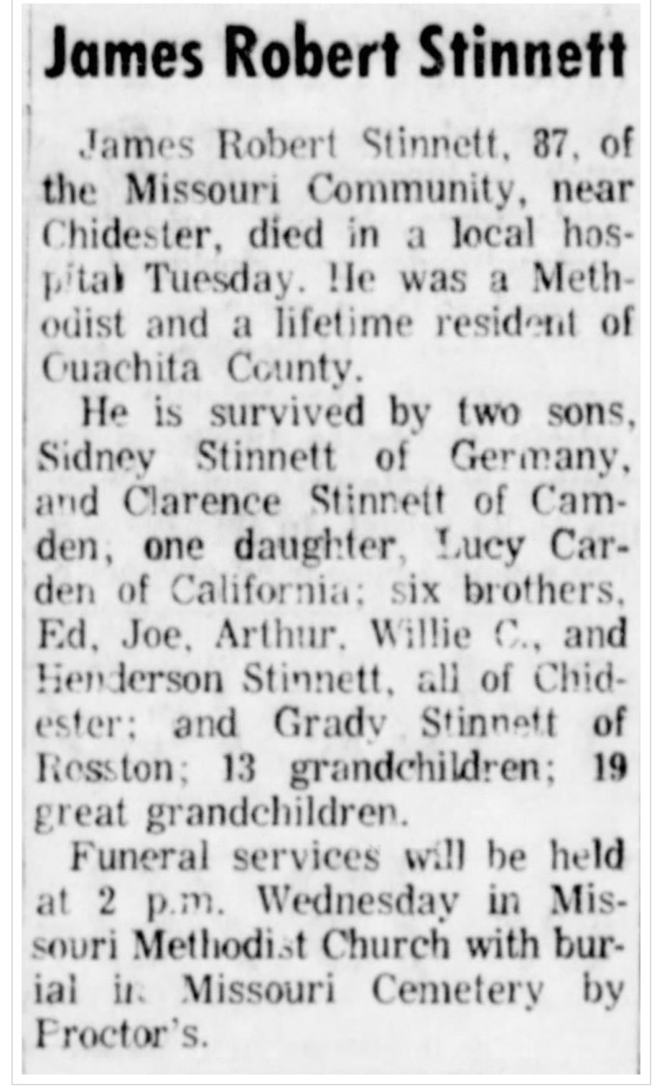
Source: The Camden News 9/26/70 (via newspapers.com)

